**SERVLET ASSIGNMENT:**

**Create a basic Servet project which displays your name.**

**package** com.jeril.servlet;

**import** java.io.IOException;

**import** java.io.PrintWriter;

**import** javax.servlet.GenericServlet;

**import** javax.servlet.ServletException;

**import** javax.servlet.ServletRequest;

**import** javax.servlet.ServletResponse;

**import** javax.servlet.annotation.WebServlet;

@WebServlet(urlPatterns ="/sample")

**public** **class** Jeril **extends** GenericServlet {

@Override

**public** **void** service(ServletRequest request, ServletResponse response) **throws** ServletException, IOException {

response.setContentType("text/html");

PrintWriter out = response.getWriter();

out.println("<html>");

out.println("<body>");

out.println("<h1>My Name Is JERIL</h1>");

out.println("</body>");

out.println("</html>");

}

}

1. <servlet>
3. <servlet-name>JerilServlet</servlet-name>
4. <servlet-class>com.jeril.servlet.Jeril</servlet-class>
5. </servlet>
7. <servlet-mapping>
8. <servlet-name>JerilServlet</servlet-name>
9. <url-pattern>/jeril</url-pattern>
10. </servlet-mapping>
11. </web-app>

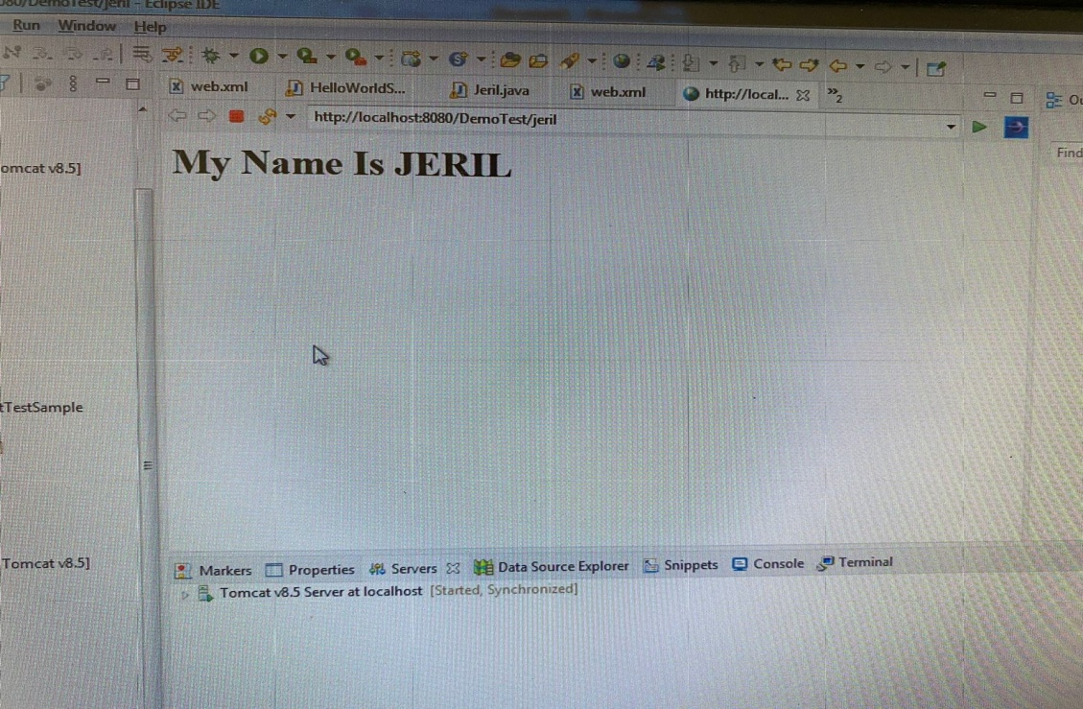

**Create a servlet project that accepts 3 user inputs and performs the addition and subtraction and multiplication and display the result on click of submit.**

**Multiplication:**

package com.jeril.servlet;

import java.io.IOException;

import java.io.PrintWriter;

import javax.servlet.GenericServlet;

import javax.servlet.ServletException;

import javax.servlet.ServletRequest;

import javax.servlet.ServletResponse;

public class multiplyservlet extends GenericServlet {

@Override

public void service(ServletRequest request, ServletResponse response) throws ServletException, IOException {

PrintWriter out = response.getWriter();

if(request.getParameter("number1")!=null && request.getParameter("number2")!=null) {

Long numb1 = Long.parseLong(request.getParameter("number1"));

Long numb2 = Long.parseLong(request.getParameter("number2"));

out.println("The multiplication result is" + (numb1) * (numb2));

}else {

out.println("Enter the valid input");

}

}

}

**HTML File:**

<form action=*"multiplyservlet"*>

<h1>Enter the value</h1></br>

<input type =*"text"* name=*"number1"*></br>

<input type =*"text"* name=*"number2"*></br>

<input type =*"submit"* name=*"submit"*></br>

**Web**:

<servlet>

<servlet-name>multiplyservlet</servlet-name>

<servlet-class>com.jeril.servlet.multiplyservlet</servlet-class>

</servlet>

<servlet-mapping>

<servlet-name>multiplyservlet</servlet-name>

<url-pattern>/multiplyservlet</url-pattern>

</servlet-mapping>

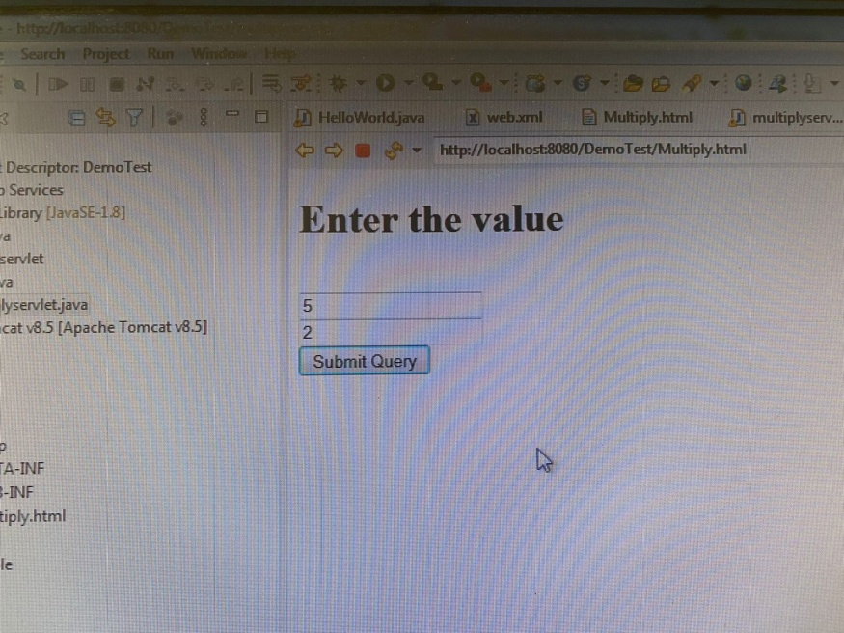

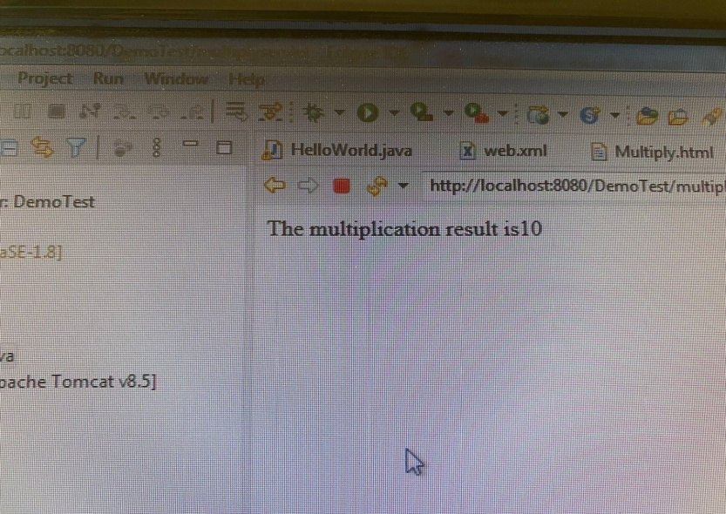

**Addition**:

**public** **class** AdditionServlet **extends** GenericServlet {

@Override

**public** **void** service(ServletRequest request, ServletResponse response) **throws** ServletException, IOException {

PrintWriter out = response.getWriter();

**if**(request.getParameter("number1")!=**null** && request.getParameter("number2")!=**null** && request.getParameter("number3")!=**null**) {

Long numb1 = Long.*parseLong*(request.getParameter("number1"));

Long numb2 = Long.*parseLong*(request.getParameter("number2"));

Long numb3 = Long.*parseLong*(request.getParameter("number3"));

out.println("The addition result is" +(numb1 + numb2 + numb3));

}**else** {

out.println("Enter the valid input");

}

}

}

**HTML File:**

<form action=*"AdditionServlet"*>

<h1>Enter the value</h1></br>

<input type =*"text"* name=*"number1"*></br>

<input type =*"text"* name=*"number2"*></br>

<input type =*"text"* name=*"number3"*></br>

<input type =*"submit"* name=*"submit"*></br>

**Web**:

<servlet>

<servlet-name>AdditionServlet</servlet-name>

<servlet-class>com.jeril.servlet.AdditionServlet</servlet-class>

</servlet>

<servlet-mapping>

<servlet-name>AdditionServlet</servlet-name>

<url-pattern>/AdditionServlet</url-pattern>

</servlet-mapping>

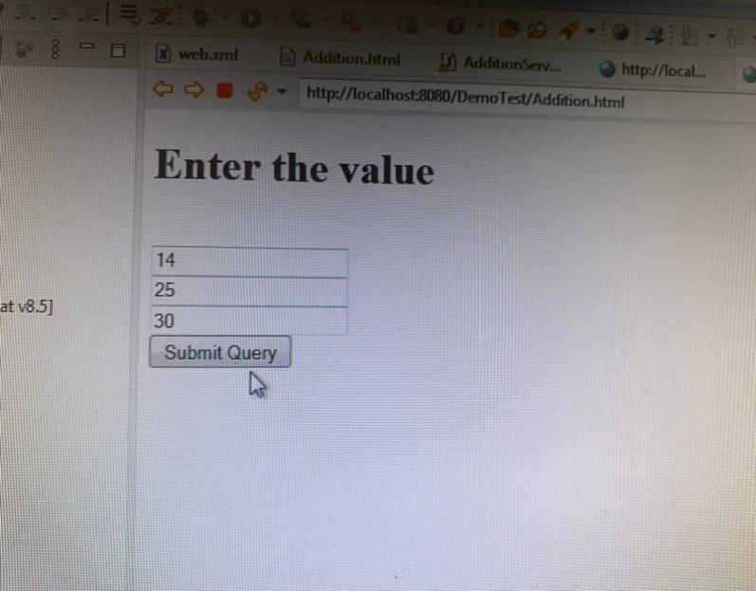

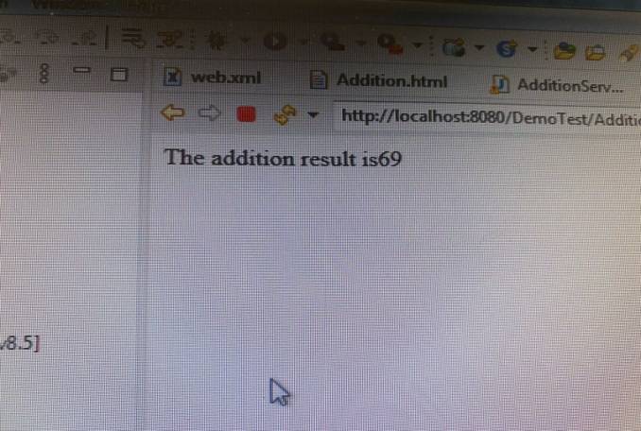

**Subraction:**

**public** **void** service(ServletRequest request, ServletResponse response) **throws** ServletException, IOException {

PrintWriter out = response.getWriter();

**if**(request.getParameter("number1")!=**null** && request.getParameter("number2")!=**null** && request.getParameter("number3")!=**null**) {

Long numb1 = Long.*parseLong*(request.getParameter("number1"));

Long numb2 = Long.*parseLong*(request.getParameter("number2"));

Long numb3 = Long.*parseLong*(request.getParameter("number3"));

out.println("The subraction result is" + (numb1 - numb2 - numb3));

}**else** {

out.println("Enter the valid input");

}

}

}

**HTML File:**

<form action=*"SubractionServlet"*>

<h1>Enter the value</h1></br>

<input type =*"text"* name=*"number1"*></br>

<input type =*"text"* name=*"number2"*></br>

<input type =*"text"* name=*"number3"*></br>

<input type =*"submit"* name=*"submit"*></br>

**Web:**

<servlet-name>SubractionServlet</servlet-name>

<servlet-class>com.jeril.servlet.SubractionServlet</servlet-class>

</servlet>

<servlet-mapping>

<servlet-name>SubractionServlet</servlet-name>

<url-pattern>/SubractionServlet</url-pattern>

</servlet-mapping>

